My First Experience with GitHub During Internship

Introduction:
Before starting my internship, I had heard about GitHub but never used it seriously. During the internship, I learned how GitHub helps developers manage projects, track changes, and collaborate efficiently. This experience gave me practical knowledge of version control and project management.
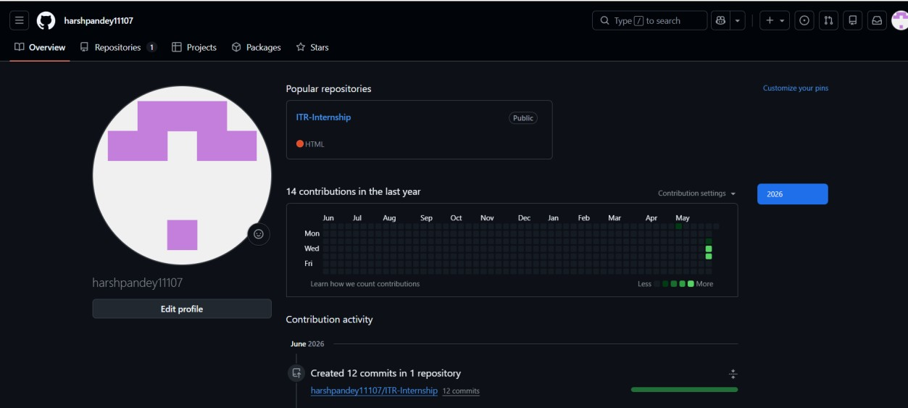

My GitHub Profile Showing Repositories and Contributions

Why GitHub is Important:
GitHub is more than just a platform for storing code. It acts as a portfolio for developers and maintains a complete history of project changes. This makes it easier to manage projects, track progress, and work effectively in teams.

What I Learned:
- During my internship, I learned:
- Creating and managing repositories
- Cloning repositories to local system
- Using Git commands such as "git add", "git commit", and "git push"
- Uploading projects to GitHub
- Maintaining README files and project documentation
- Tracking daily progress through Markdown files

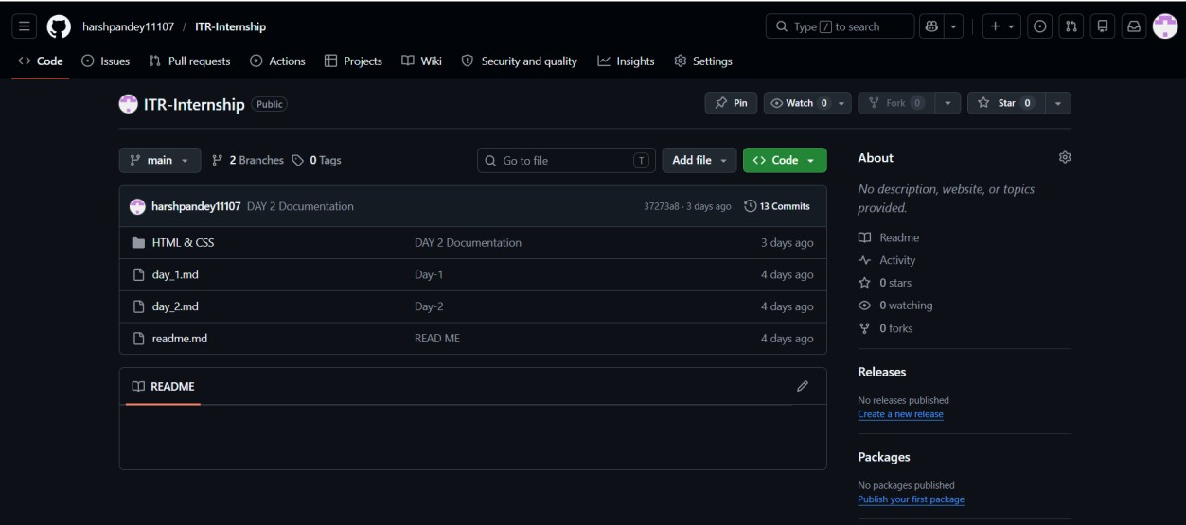

Internship Repository Containing Project Files and Documentation

Challenges I Faced:
Initially, I faced difficulties while connecting Git with GitHub and understanding commits. I also encountered errors while pushing code to repositories. However, solving these issues helped me understand the GitHub workflow better and improved my problem-solving skills.

How GitHub Improved My Workflow:
GitHub helped me:
Organize project files efficiently
Maintain daily internship records
Share projects easily with others
Keep secure backups of my work
Learn industry-standard development practices

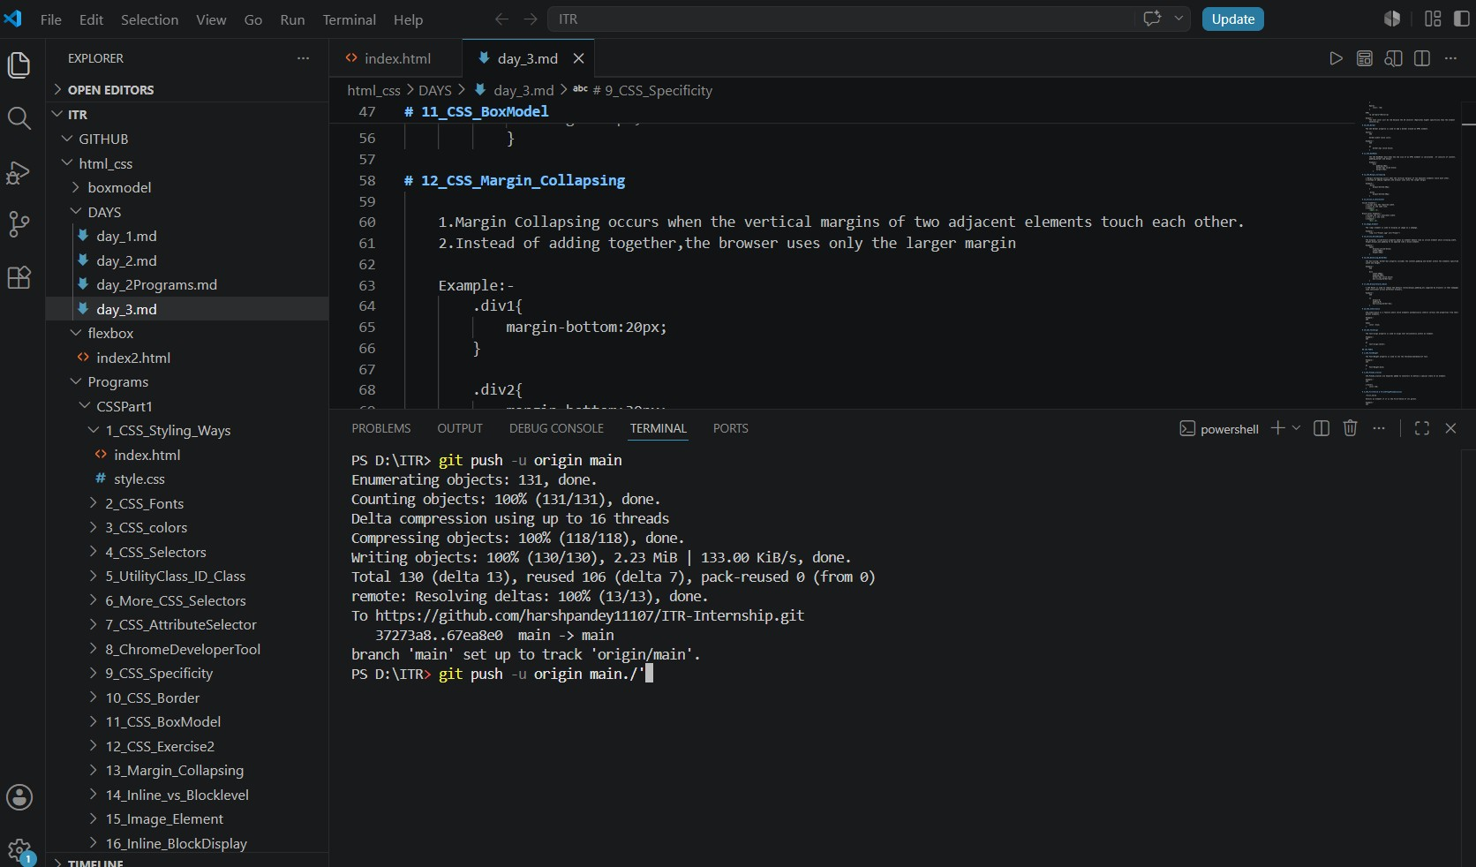

Successfully Pushing Project Files to GitHub Using Git Commands

Conclusion:
My internship introduced me to GitHub as an essential tool for software development. It not only helped me manage and share code but also taught me the importance of version control, documentation, and collaboration. Learning GitHub has improved my confidence in handling real-world development projects and prepared me for future software development work.

